1. **INTRODUCTION**

This project aims to solve a wide variety and range of basic productivity problems faced by almost everyone in our society today.

* 1. **PROBLEM STATEMENTS**

Here, we are mainly looking to solve three main problems.

* + 1. **Quadrant II Management.**

There are four quadrants of time management:

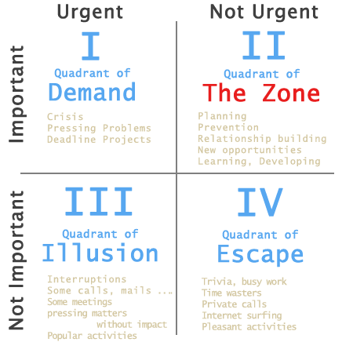

We are naturally motivated towards completing the Quadrant I tasks and do not require any help in this area.

Quadrant III tasks are an area of Illusion because they call for immediate attention and consume a lot of our time, but at the end are not productive at all.

Quadrant IV tasks can be done at any time or just completely left off and we often move to them as an ‘Escape’.

Unable to properly organize and complete Quadrant II tasks is a basic problem, eliminating which would change everything in the life on an individual and society as a whole.

Generally we do not complete these important tasks until and unless they also become urgent, thus moving to Quadrant I. The second quadrant is really the focus of all the productivity apps. Here, we not only aim to manage the second quadrant but also manipulate them. Through the use of Motivation design we would be attempting to move the Quadrant II tasks into Quadrant I, as now there are points to lose if they are not completed early and also other mechanisms as Levels and Seinfeld Calendar.

Success in life is just a matter of self-control, as a ground breaking research by Dan Ariely shows us that Self-Control in greatly co-related to success in one’s life, no matter the environment, education, background or financial conditions and no matter as to how success is measured or interpreted – in terms of money, peace of mind, happiness, happy wife or great kids.

* + 1. **Self-Measure**

We live in a world which is constantly measuring and judging us based on various criteria such as grades and bank balance, or just simple compliance with any number of absurd norms, rules and regulations of an organization of the society as a whole.

All these measures and motivation to excel in these are external to oneself. Here, we aim to build an internal measure and motivational system by which one will be able to measure and judge oneself, truly based on numbers and also what he/she really wants to do, in contrast to others’ measures and judgments which are biased towards their perception, experiences and sometimes even profits them.

* 1. **Key Actions**

These are the key actions that the users are required to do in order to benefit the most out of LifeWin.

1. Keeping Track of the time it takes you to do tasks
2. Giving points to yourself based on tasks performing
3. Tracking the time taken to complete them.
4. **Design**

LifeWin is made out of various elements, concepts and rules which make the system running.

* 1. **Goal**

The goal of the user here is to act and behave like one’s ideal self and to also gain the knowledge, skills and experience required to become one’s ideal self.

* 1. **Elements**

LifeWin has various elements such as Goals, To-do List, Habits, Habit Tracker, Timer, Pomodoro Timer, Rewards and Scoreboard, which are found in numerous different apps, but will be integrated together for the first time in LifeWin. Anyhow, it’s not about these elements, but how they are all combined together and how we translate good habits and perceptions first into motivational design and then into a mechanism in LifeWin.

* + 1. **Personal Kanban**

The Personal Kanban helps in managing goals and consists of three sections: Past, Present and Future. Having all the goals/projects that you are working on in the present helps you see if your goals are realistic or even if they are too low. We have two basic rules to be followed here:

**(i)** Daily progress has to be made towards all the Tasks in the “Present” section. If you are not able to make Daily/Weekdays or even Weekly progress towards all your tasks, it’s an indication that you are trying to achieve too much.

**(ii)** If the player is unable to complete a Goal by the deadline, a few days will be added to the deadline of the particular task, and all the tasks in the “Future” section. The postponing of all the tasks will be marked in a “Life Calendar” and/or some other UI elements.

* + 1. **To-Do List**

Tasks are divided into four sections: Today, Tomorrow, This Week and Later.

(i) Each task may or may not be assigned specific “points”.

(ii) Zero points can be assigned to a task.

(iii) Points assigned are added upon completion of the task.

* + 1. **Habits/Regular Tasks**

These are repetitive tasks, which you may have to do multiple times a day, daily, weekly or just on the weekdays. A separate log is maintained for each of the tasks and showed in the form of a calendar.

(i) Each entry must be assigned a specific “point”.

(ii) Zero points may be assigned for entries.

(iii) Points are awarded every time the repetitive task is completed.

* + 1. **Timer**

Simply tract the time a task has taken and be awarded points on the basis of time, instead of fixing points for the tasks.

(i) Users can set the amount of points they earn per hour.

(ii) Only natural number of points are added, no fractions or decimals.

(iii) Users can have their own guidelines as to what can and cannot be done while the timer is running.

* + 1. **Quick Add**

Users have the option to add points for the tasks they have completed directly, without having to enter the complete task and mark it as completed, or even run the timer. Users can add any amount of points, and we have some general category/options to quickly choose from:

Substantial Work +5

Small Task +2

Tiny Task +1

(i) Determining the points to be awarded for each non-repetitive task can be very tedious, it’s best to go with either the timer or the quick add feature.

(ii) Award points for your best efforts and not results.

* 1. **Point System**
     1. **No Negative Points**

LifeWin contains no concept of negative points, which means no (i) fines, (ii) Spending on rewards, (iii) Bonus points, due to various reasons:

1. They justify taking un-healthy and un-productive actions, if you have enough points to give the ‘fine’.
2. Spending on rewards creates a virtual economy, making it complicated.
3. Causes Over justification effect, i.e., if the rewards are removed, all the habits will vanish and the user will become further de-motivated.
4. Any changes in the system can decrease the price of an item in the virtual economy, making it very attractive to the user who can then over-consume the item in question, which can be detrimental to the user’s health.
5. Earning zero points while performing non-work activities is good enough.
6. In extreme cases, a user can instead award himself for controlling oneself.
7. Ingrains the message of “Time is Money” – the only way you can earn points is by working now and the only way you can lose points is by not working now.
   * 1. **Daily & Weekly Points**

Having a point system which is ever-increasing is ineffective, because to the human mind doesn’t recognizes the absolute value but the proportion of change. So, in LifeWin we have a dual points systems which resets daily and weekly and are thus called as daily and weekly points. Also, the user is to complete the week’s leftover work on the weekends. The system has following advantages:

1. You have to keep moving forward, no matter how well you performed in the past, it’s gone. The only thing that matters is the future.
2. Starting of each day is a new beginning, bringing excitement especially Mondays!
3. In weekends, many of the tasks in the “Habits/Regular Tasks” become inappropriate and it’s hard time trying to score the same number of points as in weekdays.
4. We do not have any “Rewards”, the weekends can be seen as the implicit reward.
5. Fits the lifestyle we all already have, i.e., enjoying weekends, going out, going home, house-hold activities.
6. Viewing the whole week as a single unit of time is what’s suggested in ‘The 7 Habits of Highly effective people’ and also ‘Getting Things Done’.
7. When we have only a Daily system, a bad start of the day, ruins everything.
8. Leaderboards comparing points across multiple days and weeks.
   1. **Win state**

At the end of each day, the player has to ask himself, “Did I do it?” and if the answer is “Yes, I did It.”, he has won the day. At the death bed, just before dying, a person’s whole life flashes before his eyes, good and bad memories, and greatest joys and deepest sorrows. Here, there is no need to ask oneself, the question “Did I do it?” is embedded in the very essence of memories, the heart just knows. You won if the answer is “yes” and lost if the answer is “no”.

1. **Example Scenarios**
   1. **Classroom**

Points for attending classes: How many and under what conditions?

Suppose we set 10 points / class, how do we determine which instances qualify and which do not? One can approach this in many ways, all of which have their own problems:

|  |  |
| --- | --- |
| **Approach** | **Trouble** |
| 10 points for attendance | You can come late to class and not concentrate, everything is fine only physical attendance matters. |
| 10 points for being mentally present in class all the time | What if you lose concentration or get distracted due to peers? You lose all your points and motivation to listen further. |
| Points as per amount of time mentally present in the class. | Cognitive load and wasting of time in calculations. Counterproductive in nature, can cause irritation and frustration. |
| Try to be your best, concentrate again if you lose your concentration, take notes, answer questions, come up to the board, and do anything you have to. At the end of the class ask yourself, “Did I earn those 10 points”? No calculations, no excuses, just go with your gut feelings. | Looks like a great solution! |

Each Approach has a different “attitude” and yields a different behavior.

Also, “attitudes” towards one problem can leak into other problems and real life outside the game. We have to be very careful in picking the behavior and attitude that we desire.

* 1. **Nail Biting**

**What people do:** Sometimes, when they notice themselves biting nails, they stop doing so and “punish” themselves a bit in the sense to say that they “curse” and “scold” themselves.

**What productive people do:** Cursing and scolding oneself is not very good here. What happens when you do not notice that you were biting nails? Nothing. The right thing to do is, whenever you notice that you were biting nails, you should keep your hands down and “reward” yourself for stopping by giving yourself a mental pat at the back.

**What LifeWin does**: Users have “Nail Biting” as one of their habits in our app, and we ask them to award themselves 1 point for each time they do stop biting their nails. We note the difference, we see that there must have been a “reward” in place of the “punishment”. In our app’s framework, we make a way to force the perception change.

* 1. **Quickly starting other tasks**

**What people do**: Knowingly or unknowingly, waste sometime after completing a task and before starting the next

**What productive people do**: Quickly switch from one task to another. Its okay to relax and take a break, but even these should be conscious and spend doing what the person really wants to do (e.g. talk with family on phone) in contrast to mindlessly browsing online.

**What LifeWin does**: Each time you interact with the app, the app tells you how much time has elapsed from the last interaction. This gives you real time feedback on how much time have you just wasted, how much time have you taken to do each of the activities.

* 1. **What is a reward/relaxation?**

**What people do:** People take expensive, big and time consuming stuff to be rewards. Fancy dinner at an expensive place, diamond rings, watching movies, junk food. What’s worse is that today’s habit formation apps supports this, if not completely based on such rewards.

**What productive people do:** Rewards are associated with time. Each moment that you spend doing something you like, can be a reward in itself. Buying a book is not a reward, the time spent reading it is. Doing your light-hearted work is also a reward. Time spent with friends and family is reward.

**What LifeWin does**: We have a ‘Rewards’ section, where the users are to enter all the relaxing and light-hearted work they are to do. There is a very thin line of difference between work and fun, mostly just cultural. Here, we break the very quadrants of time management, where a lot of what you considered ‘work’ – which indeed consumed your self-control and energy, will turn to fun. To what extent this happens and for which tasks would depend on the individual.

1. **Conclusion**
   1. **Did we solve the problems?**
      1. **Quadrant II**

Simply put, now you have to engage with the important tasks, simply because, if you don’t you lose, you will be faced with self-guilt, will not receive the sense of accomplishment/winning that you get on other days. Also, seeing a number go up if fun, if you don’t do you work, your daily/weekly points are stuck.

* + 1. **Self-Measure**

Instead of being stuck with external measures and people saying you as to what you should do, you now have your own measure, which goes up as per your own rules, tasks and goals and most importantly, you have your inner voice saying what your worth is, what you should do, what’s right and what’s wrong.

* 1. **Benefits of Using LifeWin**
     1. **Benefits of Goal Tracking**
* [Increases motivation to achieve](http://teaching.monster.com/benefits/articles/9440-effective-goal-setting-for-students): Tracking your goals will also motivate you to reach even more of your goals. You will be able to look back and see just how far you have come in order to reach your goals. You’ll realize that if you can do that, anything is possible. Without the tracking, you won’t have a visual reminder of your successes.
* [Increases a sense of pride and satisfaction in performance](http://teaching.monster.com/benefits/articles/9440-effective-goal-setting-for-students)
* [Improves self-confidence](http://teaching.monster.com/benefits/articles/9440-effective-goal-setting-for-students): Doesn't it feel good when you accomplish something? When you write down how much closer you are to your goal, you feel good about yourself.
* [Gives a Sense of Purpose](http://www.livestrong.com/article/113768-importance-setting-goals/): That is what is important in life as a life without aim is similar to an arrow without an aim to shoot. When you track goals for yourself, you give meaning to your daily routine.
* [Helps develop responsibility and self-efficacy](http://www.livestrong.com/article/113768-importance-setting-goals/): Tracking your goals will not only make you want to work hard but also make you feel responsible whether it may be your own success or failure.
* [Helps develop clear plans](http://www.livestrong.com/article/217375-advantages-and-disadvantages-of-goal-setting/)
* [Increases awareness of one’s strength and weaknesses](http://www.livestrong.com/article/217375-advantages-and-disadvantages-of-goal%20setting/): Setting goals will make you work hard in that particular direction and make you aware of your own strengths and weaknesses.
* [Creates a positive can-do attitude](http://www.selfgrowth.com/articles/The_Benefits_of_Goal_Setting.html)
* [Develops self-discipline and will power](http://www.selfgrowth.com/articles/The_Benefits_of_Goal_Setting.html): If reaching a goal was so easy, we wouldn’t have to set them in the first place. Tracking your goals allows you to see where you might’ve slipped up and slowed down your progress. When you find the areas in your routine that aren’t beneficial to reaching your goals, you can discipline yourself into changing your normal habits.
* Increases focus by providing a direction
* [Helps make better use of time](http://www.relaxfocusenjoy.com/7-benefits-of-goal-setting): When you track your goals, you become aware of how much closer you are to your deadline. The closer you get to your goal, the more you prioritize your time for things that are required to reaching your goal.
* [Helps get faster results](http://www.relaxfocusenjoy.com/7-benefits-of-goal-setting/)
* [Gives you a sense of control](http://www.goal-setting-motivation.com/tag/benefits-of-goal-setting/)
* Helps set specific priorities
* [Promotes a healthy sense of failure](http://www.livestrong.com/article/217375-advantages-and-disadvantages-of-goal-setting/)
* Limits stress
* [Helps achieve quick results](http://smallbusiness.chron.com/benefits-goal-setting-2511.html): Believe it or not, you have the power to have some control over the results and your future. Want to be 10 lbs lighter 5 weeks from now? Make it a goal. Achieve it! Want to save your money by eating out less? Make that your goal!
  + 1. **Benefits of To-Do Lists**

• [Creates Order](http://www.robinskey.com/)

• [Helps Prioritize](http://www.robinskey.com/): You have many things to do in a particular day, but some are certainly more important and time-sensitive than others. You can organize your to-do list in order of priority.

• [Creates Accountability](http://www.robinskey.com/)

• [Helps in Rescheduling and organizing your time:](http://www.robinskey.com/) can be used to document the task(s) you have to complete in a particular day, week, month or year.

• [Relieves Stress](http://www.robinskey.com/): You may able to prioritize your things which may help you to tackle the most important jobs first and not waste time on trivial tasks. Thus you don't get stressed by the large number of unimportant jobs.

• [Lets you coordinate similar tasks](http://www.ismckenzie.com/)

• [Tracks your progress](http://www.ismckenzie.com/): Helps you keep a realistic view of things. One of the important aspect of time management is not pushing yourself over the edge trying to complete everything you've put down. There would be days when you may be able to cross off all the items and some days will be there where you can't accomplish anything.

• [Reduces Anxiety](http://www.listproducer.com/)

• [Improves Focus](http://www.listproducer.com/)

• [Boosts Your Brain Power](http://www.listproducer.com/)

• [Organizes Your Thoughts](http://www.listproducer.com/)

• [Increases Self-esteem and Happiness](http://www.listproducer.com/): It feels great to cross things off your list. This is an undeniable truth as writing down the list of things to do on a piece of paper and striking those jobs after completion makes one feel great. ()

• [Improves Memory](http://www.toodledo.com/)

• [Creates Motivation](http://www.toodledo.com/)

• [Provides Higher Efficiency](http://zubair-ahmed.hubpages.com/hub/5-Benefits-of-To-Do-Lists-Time-Management-Get-Organised)

* + 1. **Benefits of Habit Tracking**
* [More probability of accomplishing tasks](http://www.earlybirdmom.com)
* [Shows up areas of weakness or strength](http://www.earlybirdmom.com/): Tracking shows up areas where you are weak (and strong). If I say I want to get better grades, but I don’t consistently put efforts, then I know I need to create some better systems.
* [Helps you know yourself](http://www.earlybirdmom.com/): After tracking my eating for a few weeks, I noticed that drinking even a tiny glass of wine at night made me sleep poorly and feel terrible the next morning. If I hadn’t tracked my diet, I doubt I would have made that connection.
* [Improves or builds will power](http://blog.bufferapp.com/)
* [Enhances behavior](http://blog.bufferapp.com/)
* [Measure progress](http://blog.bufferapp.com/): Tracking gives you a very clear idea of how different changes affect you, and helps you more quickly identify what is and is not working.
* [Inspires change](http://blog.bufferapp.com/)
* [Provides a reality check](http://blog.bufferapp.com/)
* Creates a sense of achievement: Tracking also helps you celebrate your successes.
  + 1. **Benefits of Using a Timer**

• [Timing allows for better focus](http://michellemonettemusic.wordpress.com/): .Many people especially those who forgets many things, lose track of time and tend to get lost in their thoughts. Timers are useful for such people to stay on a single task.

• [Better time management](http://michellemonettemusic.wordpress.com/): You can organize your time better. Timers are great for keeping track of exactly how much time you spend practicing something specific.

• [Timing can help prevent injury](http://michellemonettemusic.wordpress.com/): It's not unusual to lose track of time, two or three hours can go by without even noticing. Through timer we can avoid these type of difficulties.

• [Unburden your brain](http://strangelibrarian.org/)

• [Make things into a game](http://strangelibrarian.org/)

• Increases efficiency: .Timer allows you to focus better and being able to focus on things you are working will give you efficient work.

• Procrastination is reduced

* + 1. **Benefits of Using a Pomodoro Timer**

• [The frequent breaks keep the mind fresh and focused](http://www.lifehack.org/articles/productivity/the-pomodoro-technique-is-it-right-foryou.html)

• [It helps in cranking through projects faster by forcing the user to adhere to strict timings](http://www.lifehack.org/articles/productivity/the-pomodoro-technique-is-it-right-for-you.html)

• [Improves concentration](http://www.fluent-time-management.com/pomodoro-technique.html): As the Pomodoro technique is a way of managing time and becoming more productive by managing tasks in 25 minute intervals, it provides pure concentration of focus that makes you realize how different the quality of your work has become.

• [Gives a feeling of accomplishment](http://www.fluent-time-management.com/pomodoro-technique.html): Starting with a productivity technique is the manifestation of your willingness to do something about the way you work, how you spend time working and how you value your time.

• [Improves work process](http://agilelifestyle.net/the-pomodoro-technique33554554): It increases determination to achieve your goals, improves your ability to focus by cutting down on interruptions.

• [Strengthens perseverance](http://agilelifestyle.net/the-pomodoro-technique33554554)

• [Boosts motivation](http://agilelifestyle.net/the-pomodoro-technique33554554)

• [Increases awareness of decision- making](http://agilelifestyle.net/the-pomodoro-technique33554554)

• [Helps conquer our wandering minds](http://www.jeffkorhan.com/2010/08/increase-your-work-efficiency-with-the-pomodoro-technique.html)

• [Helps cuts down on procrastination](http://www.lifehacker.co.uk/2014/07/14/pomodoro-technique)

• [Helps you track effort](http://www.lifehacker.co.uk/2014/07/14/pomodoro-technique)

• [Helps in faster learning](http://www.classicalguitarshed.com/pomodoro/)

• [Teaches to prioritize](http://www.classicalguitarshed.com/pomodoro/)

• Less intrusive than physical timer

* + 1. **Benefits of Gamification of Life**

## **In terms of child education:**

• [It develops a positive attitude towards dry subjects like mathematics](http://www.emergingedtech.com/2012/12/8-research-findings-supporting-the-benifits-of-gamification-in-education/): good user interface influences students to complete their work even in dull subjects

• [Children constructing their own video games, experience increases cognitive and social growth](http://www.emergingedtech.com/2012/12/8-research-findings-supporting-the-benifits-of-gamification-in-education/)

• [It provides the most beneficial context for the child’s development especially ADHD children](http://www.emergingedtech.com/2012/12/8-research-findings-supporting-the-benifits-of-gamification-in-education/): Allows an increase in the activity of the regions of the brain to allow for adequate development

• [It increases a child’s attention span](http://www.emergingedtech.com/2012/12/8-research-findings-supporting-the-benifits-of-gamification-in-education/)

* Lessens disruptive behavior
* [Playing scary and violent video games help children master their fears in real life](http://www.emergingedtech.com/2012/12/8-research-findings-supporting-the-benefits-of-gamification-in-education/): They prepare us to face a situation which we may face in our future, makes our brain sharp.

**In terms of business:**

• Increase in influence

• [Gamification models may also be applied to support greater employee productivity](http://www.gamification.co/2013/04/11/what-are-the-benefits-of-gamification/)

• [Provide the mechanics to supply an environment of participation](http://www.gamification.co/2013/04/11/what-are-the-benefits-of-gamification/)

• [Helps collect powerful customer data](http://www.cio.com/article/2384745/it-organization/5-key-benefits-gamification-brings-to-your-business.html)

• [Helps in giving back to the communities connected to them by using games](http://www.cio.com/article/2384745/it-organization/5-key-benefits-gamification-brings-to-your-business.html)

• [Helps in reminding the customer that the company is always connected with them](http://www.cio.com/article/2384745/it-organization/5-key-benefits-gamification-brings-to-your-business.html)

• [Helps unlock the true potential and streamline business processes through collaboration](https://www.304.ibm.com/connections/blogs/socialbusiness/entry/gamification_unlocking_hidden_collaboration_potential2?lang=en_us).

• [Younger and older generations both, identify with this gamification and reward system](https://www.304.ibm.com/connections/blogs/socialbusiness/entry/gamification_unlocking_hidden_collaboration_potential2?lang=en_us)

• [Helps provide a new way to drive performance improvement](https://www-304.ibm.com/connections/blogs/socialbusiness/entry/gamification_unlocking_hidden_collaboration_potential2?lang=en_us)

* Promotes motivation and goal tracking
* Promotes Literacy and Building Membership
* [Allows for Educational Achievement](http://blogs.clicksoftware.com/clickipedia/top-25-best%20examples-of-gamification-in-business/)

1. **Implementation**

The project has been partly implemented. Here are some screenshots:

1. The Login/Signup page

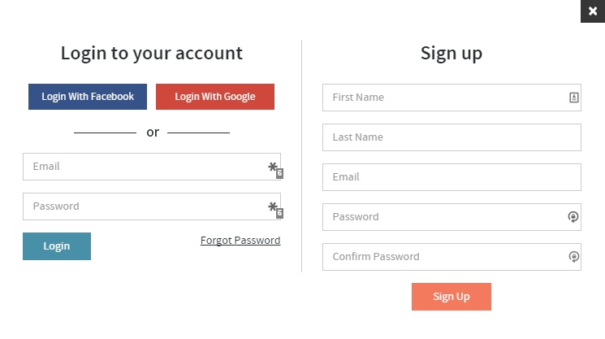

1. To-do List

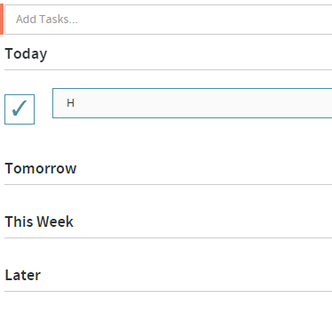

1. Goals Page

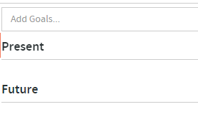

1. Habits Page

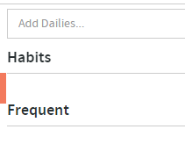

1. Scoreboard



1. Menu Options

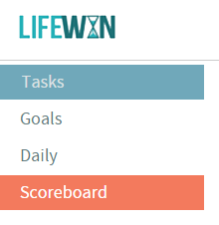

1. Timer

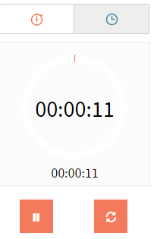

**REFERENCES**

1. Hunicke, Robin, Marc LeBlanc, and Robert Zubek. "MDA: A formal approach to game design and game research." Proceedings of the AAAI Workshop on Challenges in Game AI. 2004.
2. Fullerton, Tracy. Game design workshop: a playcentric approach to creating innovative games. CRC Press, 2014.
3. Koster, Raph. Theory of fun for game design. “O’Reilly Media, Inc.", 2013.
4. Ermi, Laura, and Frans Mäyrä. "Fundamental components of the gameplay experience: Analysing immersion." Worlds in play: International perspectives on digital games research (2005): 37.